|  |  |
| --- | --- |
| Title | **Risk assessment** |
| Description | Hazard analysis and risk assessment |
| Organization | NRC «Kurchatov Institute» – ITEP |
| Valid for: | FAIR Contract № *CC2.5.6.3.1*  Work Packages: PSP 2.5.6.3.2 |

**Document History**

|  |  |  |  |  |
| --- | --- | --- | --- | --- |
| Version | Created, date | Reviewed, date | Approved, date | Comment |
| v 1.0 | Liakin Dmitry  25.5.2020 | Date:  Signature: | Date:  Signature: | Initial release |
|  |  |  |  |  |

**Signatures**

|  |  |  |
| --- | --- | --- |
| Created, date | Reviewed, date | Approved, date |
| Liakin Dmitry  Research Scientist  Date 25.5.2020  Signature: | Date:  Signature: | Date:  Signature: |

**Table of Contents**

|  |  |  |
| --- | --- | --- |
| Preamble | 3 | |
| 1. Specification | 4 |
| 2. Functional Description | 4 |
| 3. Applicable Documents | 5 | |
| 4. Hazard Analysis and Risk Assessment | 6 |
| 5. Risk Assessment Table | 8 |
| 6. Warning Signs and Boundaries | 11 |
| Annex | 12 |
| *Specifications and Guidelines* | *12* |

**Preamble**

This document describes the processes used by ITEP to identify and analyze hazards and assess risks associated with the life cycle of the Beam Diagnostic (BD) component Tune and Longitudinal diagnostics, Schottky Pickup for the FAIR Collector Ring (CR) System.

A hazard is defined as a condition or activity that, if left uncontrolled, can result in an equipment failure and/or personnel injury or illness.

A hazard analysis is used to identify and control hazards while performing work, both scientific and operations. Also hazard analysis evaluates hazards in the workplace and contains descriptions of the location, task, hazard and controls.

A risk assessment evaluates the potential consequence of exposure to a hazard.

**Standards of Performance**

Managers shall analyze work for hazards, authorize work to proceed and ensure that work is performed within established controls.

All staff and users shall identify, evaluate and control hazards in order to ensure that work is conducted safely and in a manner that protects the environment and the public.

1. **Specification**

The Risk analysis is oriented to the hazards during the life cycle of shottky pickup for the FAIR Collector Ring (CR) System.

Comprises items related to the Work Packages: PSP 2.5.6.3.2.

The detailed information about Schottky Pickup for the Collector Ring (CR) is described in detailed specification – *F-DS-BD-34e_Special_SchottkyPickup_CR_v2.5_docx_cpdf* – located at https://edms.cern.ch/document/1560768/2.5.1.

The Risk analysis is applied to production and testing; shipment, transportation and storage; installation and commissioning; operation; adjustment; testing; maintenance and repair; decommissioning and dismantling of beam position monitor system.

1. **Functional Description**

**The product limits**

* Use limits (intended use/not intended use)

Schottky Pickup is used for primary diagnostics (Tune and Longitudinal) of particle beams at all stages of the operation of the CR ring. Warranties are invalid if you do not use the product for its intended purpose.

* Spatial boundaries

Total dimensions: 800 mm × 830 mm × 1753 mm (length × width × height)

Required space: 804 mm × 830 mm × 1753 mm (length × width × height)

* Work and storage area

Be sure you keep the product in a dry place that cannot span high humidity. Storage temperature is from 5°C to 40°C, storage humidity is from 30% to 70%. The schottky pickup is intended for use in a closed electrical installation at a temperature from 15°С to 45°С and humidity from 30% to 70%.

**Brief description of the product**

Schottky Pickup is designed for non-perturbative beam diagnostics, which allow you to measure the most fundamental beam parameters like e.g. revolution frequency, momentum spread, incoherent betatrone tunes. Moreover, Schottky signals can be used for the more advanced diagnostic of the machine chromaticity, rms transversal beam emittance or even for the monitoring of the beam intensity for very low-current beams. Schottky measurements can be applied to bunched as well as un-bunched (coasting) beam.

The Schottky Pickup consists of (see Fig. 1):

* One diagnostics vacuum chamber with flanges
* Four sensor plates for horizontal / vertical detection planes with strip line geometry and 50 Ohm characteristic impedance mounted on diagnostics vacuum chamber
* Four isolated mounting elements for all sensor plates
* Four ground plates (integrated in vacuum chamber walls or tunable for 50 Ohm matching).
* Eight 50 Ohm matched and rf compliant signal connections between sensor plate and vacuum feed-through
* Eight UHV signal feed-troughs (two per plate ) with N-type female connectors on the air side
* Girders and supports

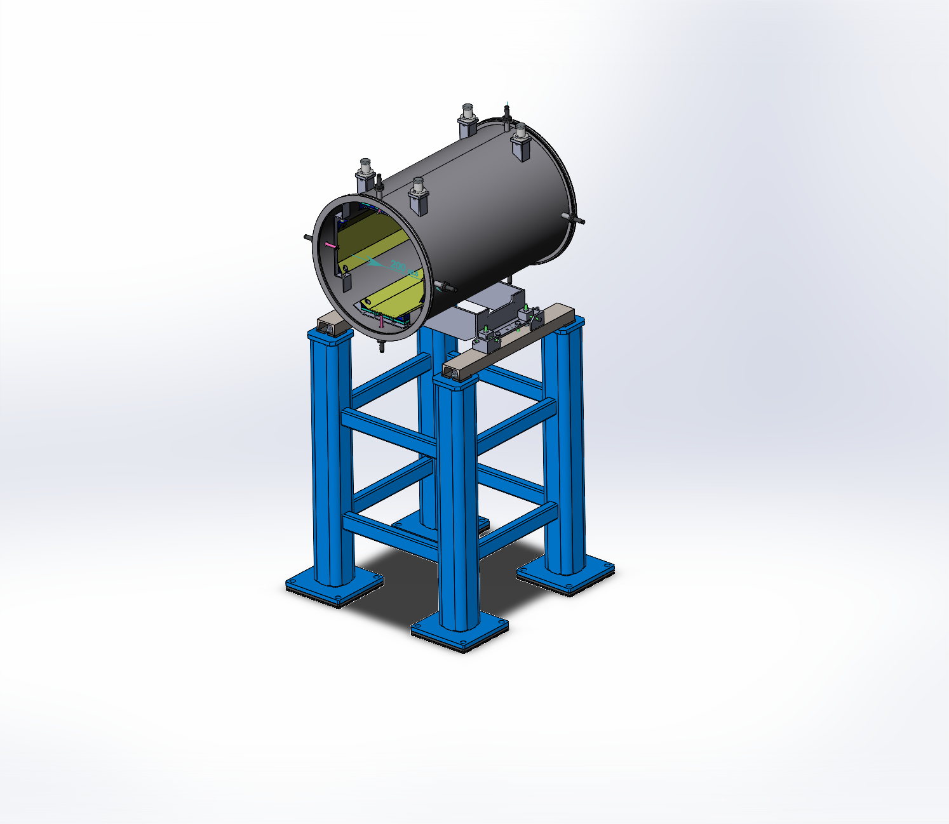

Fig. 1. Preliminary 3D model of a Schottky Pickup.

1. **Applicable Documents**

*Applicable Specification, Laws and Regulations*

The Schottky Pickup for the FAIR Collector Ring (CR) System will be designed and manufactured in compliance with the FAIR Specifications (Annex), according to the best ITEP engineering practice and applying the following laws and regulations:

*ISO 12100:2010*

*Federal Law 184-FZ On Technical Regulation, dated 27.12.2002*

*GOST R ISO 31000-2018 Risk management. Principles and guidelines.*

*GOST R ISO/IEC 31010:2019 Risk management. Risk assessment techniques.*

*GOST R 51901.1-2002 Risk management. Risk analysis of technological systems.*

*GOST R 51901.11-2005/ IEC 61882:2001 Hazard and operability studies (HAZOP studies) –*

*Application guide.*

*GOST 27.301-2011 Dependability in technics. Dependability prediction. Basic principles.*

*GOST 27.310-95 Dependability in technics. Failure mode, effects and criticality analysis. Basic*

*principles.*

ITEP declares that the Schottky Pickup can be safely operated, if handled and used in the specified way in the accelerator tunnel / at the test bench according to the ITEP Installation and Operation Manual, *FCRDSCH_Installation_Operation_manual*.

*Applicable EU Directives*

|  |  |  |  |  |
| --- | --- | --- | --- | --- |
| **Directive** | **Description** | **True** | | **Justification for the decision, measures** |
| **Yes** | **No** |
| 2006/42/EG | Machine Directive | + |  | Transportation and installation process |
| 2006/95/EG | Low Voltage Directive | + |  | The ~~magnet~~ is electrical equipment designed to operate at a nominal voltage of 220 V for alternating current |
| ~~2014/68/EU~~ | ~~High Pressure Equipment Directive~~ | ~~+~~ |  | ~~The magnet is cooled by water with a pressure of up to 10 bar~~ |
| ~~2004/108/EG~~ | ~~Electromagnetic Compatibility~~ | ~~+~~ |  | ~~The magnet contains a large stored energy and requires a big power~~ |

1. **Hazard Analysis and Risk Assessment**

A risk assessment is carried out in a few steps in accordance with the following documents: *GOST R ISO 31000-2018 Risk management. Principles and guidelines.*

*GOST R ISO/IEC 31010:2019 Risk management. Risk assessment techniques.*

* Set the limits of the product;
* Identify hazards;
* Assess the risk;
* Define safety objective and take protective measures;
* Check the effectiveness of the measure;
* Carry out further risk mitigation measures.

A risk assessment evaluates the potential consequence of exposure to a hazard. The risk assessment process builds on the hazard analysis and determines risk based on severity of the undesired consequence and likelihood of the consequence occurring.

The risk assessment process identifies the hazards, analyzes those hazards against risk and assigns a risk level. Using the risk level, controls are established to reduce the risk to an acceptable level.

**Impact (I)/ Severity Evaluation Criteria**

|  |  |  |
| --- | --- | --- |
| **Effect** | **Criteria: Severity of Effect** | **Rank** |
| Disaster | Complete loss of system or major sub-system and potential for hazard to life. | 5 |
| Severe | Complete loss of primary function. Critical component and/or assembly destroyed or put out of action. | 4 |
| High | Part loss or limitation of primary function and/or secondary function. | 3 |
| Low | Inconvenience or difficulty in achieving certain functions and/or very delayed project finish. | 2 |
| Minor | Inconveniences observed in certain operation. | 1 |

**Probability of Occurrence (PoO)**

|  |  |  |
| --- | --- | --- |
| **Rates** | **Criteria: Occurrence Rates** | **Rank** |
| Very high | Very high number of failures likely. | 5 |
| High | Frequent failure likely. | 4 |
| Moderate | Moderate number of failures. | 3 |
| Low | Few failures ever expected. | 2 |
| Exceptionally  low | Very remote possibility of failure. | 1 |

**Risk Rating**

|  |  |  |
| --- | --- | --- |
| **Risk level** | **Risk potential** | **Measures** |
| 4 | Very high | The measures taken are not sufficient to mitigate the risk sufficiently. |
| 3 | High | Measures with increased protection are urgently needed. |
| 2 | Medium | Measures with normal protective effects necessary. |
| 1 | Low | Organizational and personal measures possible. |

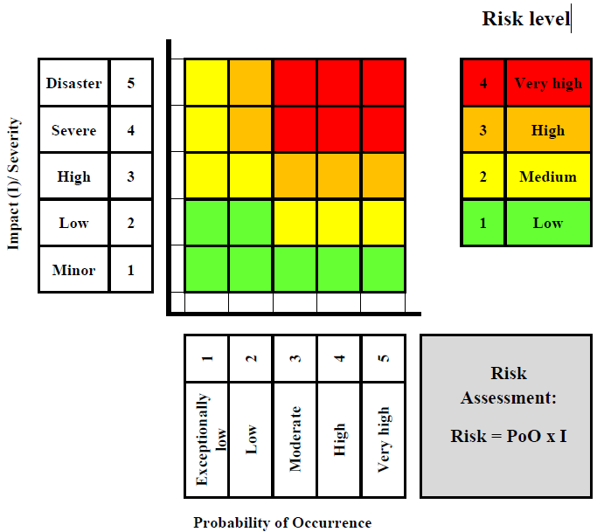

1. **Risk Assessment Table**

ITEP conduct hazard analysis and risk assessment to identify the hazards and appropriate controls.

The hazard-check list of the product is presented in the table below.

The risk assessment is oriented to hazards. The life phases of the product are identified with symbols (A, B, C, etc.) that mean:

|  |  |
| --- | --- |
| **Symbol** | **Life cycle of the product** |
| A | Production & testing |
| B | Shipment & transportation & storage |
| C | Installation & commissioning |
| D | Operations |
| E | Adjustment |
| F | Testing |
| G | Elimination of faults in normal operation |
| H | Fault tracing & reparation |
| I | Maintenance & repair |
| J | Decommissioning & dismantling |
| ALL | All life phases of the product |

|  |  |  |  |  |  |  |  |  |  |  |  |
| --- | --- | --- | --- | --- | --- | --- | --- | --- | --- | --- | --- |
| **Risk**  **Log** |  | **Risk Identification** | | | **Risk Rating Pre-Mitigation** | | | **Risk Mitigration** | **Post-Mitigation Risk Rating** | | |
| **Risk-ID** | **№** | **Description of Risk (orientating**  **to the hazard)** | **Life cycle** | **Possible consequences** | **Probability**  **of**  **Occurrence** | **Impact** | **Risk Level** | **Mitigration Strategy** | **Probability**  **of**  **Occurrence** | **Impact** | **Risk Level** |
|  |  | **TECHNICAL RISKS** |  |  |  |  |  |  |  |  |  |
|  |  | **Mechanical hazards** |  |  |  |  |  |  |  |  |  |
| RL-001 | 1 | Dent in the vacuum vessel | BCI | Damage of parts of the schottky pickup;  Performance below  specification; | 2 | 3 | 2 | • Check that lifting eye bolts are correctly tightened;  • Check that used chains, straps and hooks have the weight rating adapted to the schottky pickup weight, corresponding number of attachment points and corresponding lifting angles.  • Schottky pickup must be properly fastened to a suitable stand to prevent any fall during installation, operation, maintenance and storage.  • Obey warning signs and boundaries.  Follow handling and installation instructions according to the ITEP Installation and Operation Manual,  *FCRDSCH_Installation_Operation_manual.* | 1 | 3 | 2 |
| RL-002 | 2 | Failure of welding joints | BCI | Damage of parts of the schottky pickup; | 2 | 3 | 2 | Carry out inspection of welding lines on a regular basis.  Follow handling and installation instructions according to the ITEP Installation and Operation Manual,  *FCRDSCH_Installation_Operation_manual*. | 1 | 3 | 2 |
| RL-003 | 3 | Schottky pickup falling  during handling | BCIJ | Damage of parts of the schottky pickup up  to complete loss of the schottky pickup ;  Personnel injury | 2 | 4 | 3 | • Check that lifting eye bolts are correctly tightened;  • Check that used chains, straps and hooks have the weight rating adapted to the schottky pickup weight, corresponding number of attachment points and corresponding lifting angles.  • Schottky pickup must be properly fastened to a suitable stand to prevent any fall during installation, operation, maintenance and storage.  • Obey warning signs and boundaries.  Follow handling and installation instructions according to the ITEP Installation and Operation Manual,  *FCRDSCH_Installation_Operation_manual.* | 1 | 4 | 2 |
|  |  | **Electrical hazards** |  |  |  |  |  |  |  |  |  |
| RL-004 | 4 | Cable breaks (power, diagnostic,  etc.) including cracks or breaks in  the insulation, failure of cable  connections | CI | Loss of equipment functionality;  Electrical shock;  Fire;  Personnel injury | 2 | 2 | 1 | • Cables must be labelled.  • Cables must be traceable, viewable and accessible.  • Cables must be protected from mechanical damage.  • Avoid creating stumbling hazards with cables.  • Regular inspection of insulation and connections.  • Braked cables must be marked, apply a do-not-use tag.  • Braked cables must be replaced. | 1 | 2 | 1 |
| RL-005 | 5 | Power / power supply failure  (supply interrupted due to  external reason) | D | Loss of equipment  functionality | 2 | 1 | 1 | Does not require any action (supply interrupted due to external reason). | 2 | 1 | 1 |
|  |  | **Humidity hazards** |  |  |  |  |  |  |  |  |  |
| RL-006 | 6 | High air humidity in the  environment around the schottky pickup | BD | Corrosion | 3 | 1 | 1 | Schottky pickup will be packed for transportation under the conditions to avoid contact of product with rain water, spatter or condensates.  Use climate-control system in the tunnel.  Carry out preventive diagnostic measures in the tunnel on a regular basis. | 2 | 1 | 1 |
|  |  | **Radiation hazards** |  |  |  |  |  |  |  |  |  |
| RL-007 | 7 | Schottky pickup materials  may become radioactive during  operation | D | Tunnel environment radioactive contamination;  Workers exposure to radiation;  Difficulties to repair and maintenance of equipment | 2 | 4 | 3 | Use radioactivity supervision system in the tunnel.  Carry out preventive diagnostic measures in the tunnel on a regular basis.  Follow the GSI Safety Regulations. Complete the required GSI Safety Trainings. | 1 | 4 | 2 |
|  |  | **Ergonomic hazards** |  |  |  |  |  |  |  |  |  |
| RL-008 | 8 | Accidents of the vacuum vessel  sharp edges | ALL | Personnel injury | 3 | 1 | 1 | Use the rubber corner bumpers.  Use the basic Personal Protective Equipment (hard hats, safety glasses, steel tip shoes). | 2 | 1 | 1 |
|  |  | **Combination of hazards** |  |  |  |  |  |  |  |  |  |
| RL-009 | 9 | Design alteration and/or  performance below specification | A | Delays to the schedule;  Failed to reach the required field quality | 3 | 3 | 3 | The Parties shall monitor the scientific and technical progress of the Collaboration Contract activities.  The Parties shall clarify the Technical Specifications during the project development. | 2 | 3 | 2 |
| RL-010 | 10 | Lack of knowledge about GSI  site, GSI safety regulations and  procedures | ALL  excluding  AB | Damage to the personnel health due to hazards created by others | 2 | 1 | 1 | The Parties shall coordinate efforts to create and maintain a clean and organized work environment.  Follow the GSI Safety Regulations. Complete the required GSI Safety Trainings. | 1 | 1 | 1 |

1. **Warning Signs and Boundaries**

Warning sings and boundaries are used to safeguard personnel against exposure to the hazards. The Section provides a brief overview of proposed signs and postings, barricades and barriers.

Installation of warning sings and boundaries is the FAIR/GSI responsibility. Appearance, size and place of installation of warning sings and boundaries are carried out to comply with the FAIR/GSI standards.

A table of proposed Warning Sings and Boundaries:

|  |  |
| --- | --- |
| Description | Appearance |
| **WARNING SINGS** | |
| **Caution**  Heavy |  |
| **Caution**  Compressed Air |  |
| **Danger**  men working  on equipment  **Do not**  **switch on**  **or touch** |  |
| **WARNING BOUNDARIES** | |
| **Caution tape or ribbon** |  |
| **Stanchions** |  |

**Annex**

**Specifications and Guidelines**

Component: Tune and Longitudinal diagnostics, Schottky Pickup for CR (PSP 2.5.6.3.2)

**General Documents [1…5]**

[1] TDR-CR, Technical Design Report on the Collector Ring (CR)

[2] F-GS-F-01e-General_Specification, General Specification (General Specification for the FAIR Accelerator Facility Project)

**Common Specifications [10..19]**

[10] F-CS-BD-01e_Beam_Diagnostics, Common Specification Beam Diagnostics for FAIR

[11] F-CS-RF-5e_Electronics_Specifications

**Detailed Specifications [20...23]**

[20] F-DS-BD-40e DAQ

[21] F-DS-C-05e_General-Machine-Timing-System

[22] F-DS-C-06e_Timing-Receivers

[23] F-DS-BD-44e_mech_vacuumchambers_HEBT

**Development Guidelines [30…35]**

[30] F-DG-C-01e_FESA-Development-Guideline

[31] F-DG-C-02e_GUI-Guideline

**Technical Guidelines [100..199]**

[100] F-TG-V-2.1e_Stainless_Steel_for_Beam_Vacuum_Chambers

[101] F-TG-V-2.19e_Additives_for_TIG_Welding_of_Stainless_Steel

[102] F- -TG-V-2.36e_Bolts_Studs_Nuts_Washers_for_non-bakeable_UHV_Components

[103] F-TG-V-2.24e_Materials_in_UHV

[104] F-TG-V-2.25e_Forged_Blanks_for_Vacuum_Applications_Material_1.4429_ESU

[105] F-TG-V-2.5e_Vacuum_Firing

[106] F-TG-V-3.1e_Constructive_Design_of_Welding_Seams_for_Vacuum_Chambers

[107] F-TG-V-3.4e_Manufacturing_of_CF-Knife_Edge_Flanges

[108] TG-V-3.41e_COF_Gaskets

[109] F-TG-V-3.42e_Copper_Gaskets_for_ConFlat_Flanges

[110] F-TG-V-3.9e Welding of CF-Flanges on Tubes

[111] F-TG-V-5.1e_Surface_Conditions_of_Vacuum Chambers

[112] F-TG-V-6.1e_Cleaning_of_UHV_Components_Stainless_Steel

[113] F-TG-V-6.2e_Cleaning_of_Standard_Vacuum_Components

[114] F-TG-V-6.3e_Cleaning_of_Bellows_Used_in_Beam_Vacuum

[115] F-TG-V-7.1e_Mechanical_Acceptance_Test_for_UHV_Components

[116] F-TG-V-7.15e_Record_for_Factory_Acceptance_Test_(FAT)_of_Vacuum_Components

[117] F-TG-V-7.2e_Vacuum_Properties_Acceptance_Test_without_Bakeout

[118] F-TG-V-7.38e Leak Detection of UHV Components

[119] F-TG-8.18e_Recommended_Guidelines_for_Purchase_of_Vacuum_Chambers_ CR

[120] F-TG-V-9.1e_Transport_and_Packaging_of_Vacuum_Components

[121] F-TG-V-9.12e Sealing Cap for CF Flanges

[122] F-TG-V-9.4e Transportation by air cushions

[123] F-TG-V-10.14e Documentation of Results from Mechanical and Thermo-Mechanical FEM-Simulations

[124] F-TG-B-01e_Material_Selection_Radiation

[125] FAIR Technical Guideline, F-TG-B-02e DARL-T1, “Datenaustauschrichtlinie”

[126] FAIR Technical Guideline, F-TG-B-03e DARL-T2, “Datenaustauschrichtlinie”

[127] FAIR Technical Guideline, F-TG-MDS-en-KRL, Konstruktionsrichtlinie (KRL)

[128] FAIR Technical Guideline, F-TG-S-2.17e General construction norms

[129] F-TG-ET-01e_Electrical_Design_Rules_and_Regulations

[130] F-TG-C-01e_Ethernet-Network-Connectivity

[131] F-TG-C-02e_Control-System-Equipment-Interfaces

[132] F-TG-T-01e_Transport

[133] F-TG-T-02e_Existing_Infrastructure

[134] F-TG-T-03e_Installation

[135] F-TG-B-0.5e_CID_and_Barcode

[136] F-TG-S-3.51e Non-modular individual stand_steel

[137] F-TG-S-3.50e Alignment bridges

[138] F-TG-A-3.55e_Layout_of_a_fiducial_target_seat

**Special Documents and Technical Notes [200...]**

[200] V. R. Schaa, F. Peldzinski, M. Kühne and Bayer, Wolfgang, "System for Nomenclatures of Accelerator Devices at FAIR & GSI," [Online]. Available: https://wwwacc.gsi.de/wiki/Accnomen.

[201] S.Chattopadhyay, Some Fundamental Aspects of Fluctuations and Coherence in Charged-Particle beams in Storage Rings, CERN Yellow report 84-11, October 1984

[202] D. Boussard. Schottky Noise and Beam Transfer Function Diagnostics, CERN SPS: 86 (1986).

[203] R. Singh et al. , Understanding The Tune Spectrum Of High Intensity Beams, Proc.of IBIC 2013, p.941, Oxford, UK

[204] King-Yuen Ng, Impedances Of stripline Beam-Position Monitors, Particle Accelerators, 1988, Vol. 23, pp. 93-102

[205] A. Blednykh#, W. Cheng, S. Krinsky, Stripline Beam Impedance, Proceedings of PAC2013, Pasadena, CA USA

[206] G.R. Lambertson, “Dynamic Devices-Pickups and Kickers,” in Physics of Accelerators, eds. M. Month and M. Dienes, AIP conf Proc. 153, 1414 (1987).

[207] D. A. Goldberg and G. R. Lambertson, “Dynamic Devices a Primer on Pickups and Kickers” LBL-31664, Nov. 1991.

[208] F. Nolden, Instrumentation and Diagnostics Using Schottky Signals, Proceedings DIPAC 2001

[209] J. Bosser, Beam Instrumentation, CERN-PE-ED 001-92